Лабораторная работа №5

Вагапов Рафаэль ИБ-214

№2

2,3

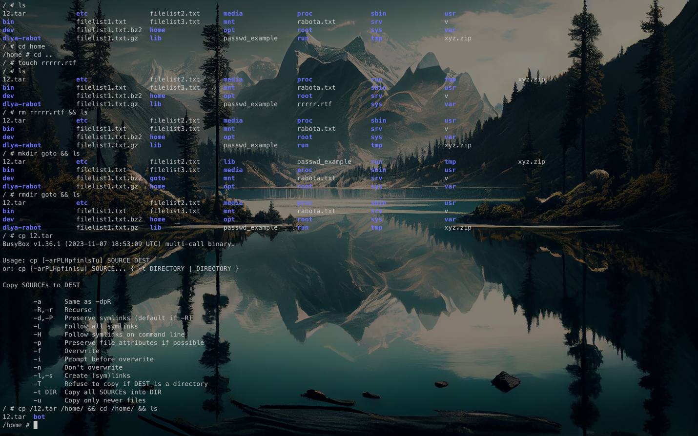



4

mkdir /home/cat1

mkdir /home/cat1/cat2 /cat1/cat3

mkdir /home/cat1/cat2/cat3

mkdir /home/cat1/cat3/cat4

mkdir /home/cat1/cat2/cat5

mkdir /home/cat1/cat2/cat3/cat6 /home/cat1/cat2/cat3/cat7

mkdir /home/cat1/cat8

ln -s /home/cat1/cat2/cat3/cat6 /home/cat1/cat8/link_to_cat6

5

find ~/cat1 -type d | sort

find ~/cat1 -type d | sort | uniq -d | xargs rm -rf

6

rm ~/cat1/cat8/link_to_cat6

7

mkdir dir

date > dir/date

echo $(date) > dir/date

date +"%Y-%m-%d" > dir/date

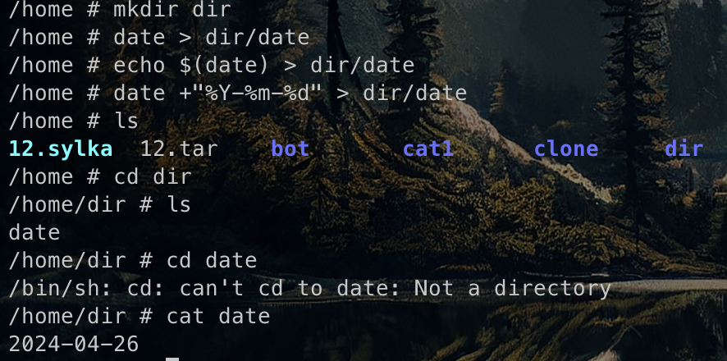

8

ln -s ~/dir/date ~/link1

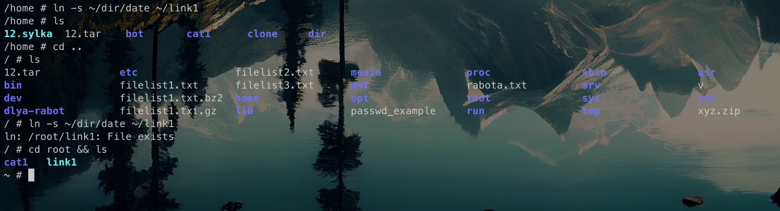

9 не понятно (????????????)

10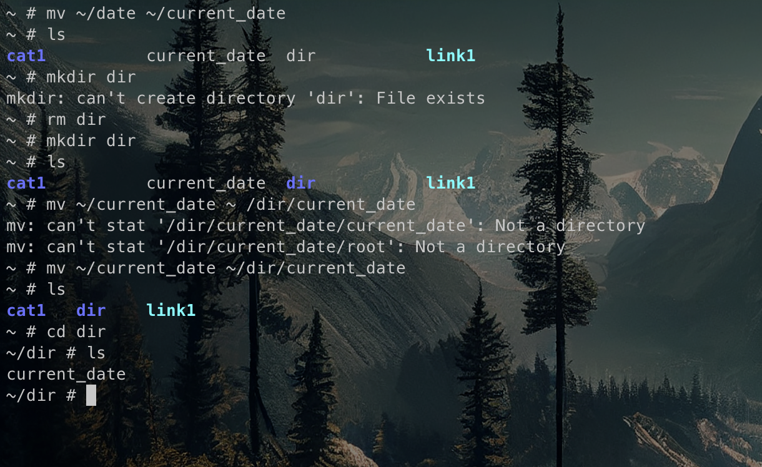

11

cp ~/dir/current_date ~ (ну оно и так там)

12

tree /

